Lake St. Clair Metropark – March 24, 2018

One of the first Oakland Owlet field trips this year took place on an extremely cold Saturday morning at Lake St. Clair Metropark. Eight birders ventured to the park to see the resident Great-horned Owl. The GH Owls have a long history at the park. The story behind the owls in the tub started in 1991 when a five-week-old owlet was blown out of the nest during a storm on April 16. The nest was destroyed, but the park staff contacted Tom Heatley, a local bird bander who specializing in banding raptors. Heatley placed an aluminum nesting tub in a tree for a safer and more secure nest option for future years. By the end of 2017, 39 owlets have been fledged from this tub. The nature center staff keeps track of the owls using this nest. The Oakland Audubon group was lucky to meet Tom Heatley at the nest. Heatley regularly visits to monitor the owls and led the group to his favorite viewing stops nearby spotting both parent Great-horned owls, a Screech owl using a Wood Duck nest box and so much more. Young birder, Henry, added to his life list some of the most amazing birds found in Michigan.
Thirty-two species were seen during the trip including some great ducks along the shoreline of Lake St. Clair. The encounter with Tom Heatley enriched the trip exponentially. The group stopped in the fabulous nature center at the park to get out of the cold.
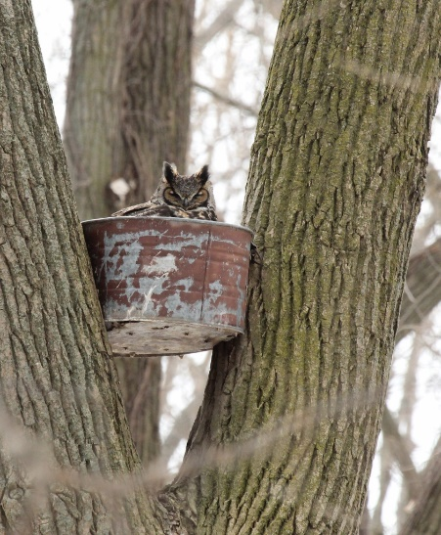
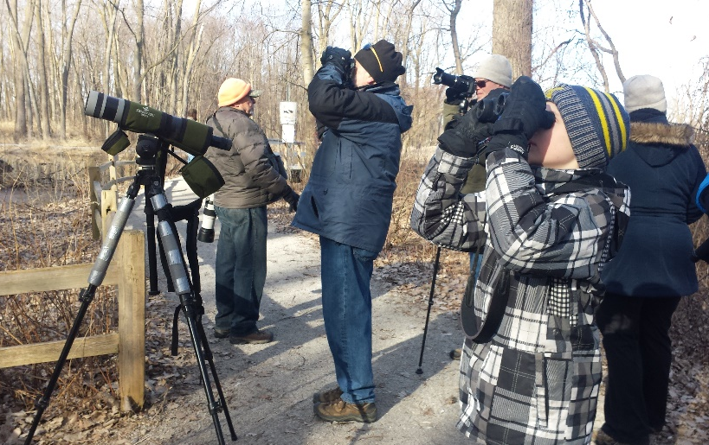
Photo credit – group photo Kathleen Dougherty & Owl in Tub – from internet - unknown

Checklist – March 24, 2018
Canada Goose
Mute Swan
Northern Shoveler
American Wigeon
Mallard
American Black Duck
Ring-necked Duck
Bufflehead
Common Merganser
Bald Eagle
Red-tailed Hawk
Sandhill Crane
Ring-billed Gull
Herring Gull
Mourning Dove
Eastern Screech-Owl
Great Horned Owl
Red-bellied Woodpecker
Downy Woodpecker
American Crow
Black-capped Chickadee
Tufted Titmouse
American Robin
European Starling
American Tree Sparrow
Song Sparrow
Northern Cardinal
Red-winged Blackbird
Brown-headed Cowbird
Common Grackle
House Finch
House Sparrow

