Conservation Efforts For The Hudsonian Gotwit
Although there are numerous research efforts ongoing to facilitate bird conservation, Smithsonian Magazine (January/February, 2022 issue) published a fascinating article about those associated with the Hudsonian Godwit. Below are some highlights of that article. Currently, there are fewer than 70,000 Hudsonian Godwits left. Researchers believe the Alaskan populaton is in decline. The Godwit population in Manitoba, Canada has declining 3.5% annually.
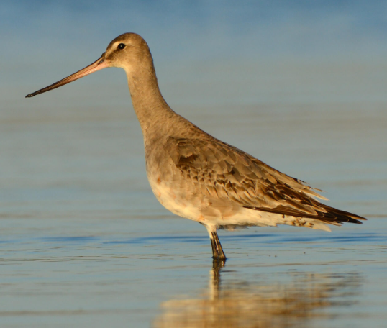
National Audubon Photograph of a Hudsonian Godwit
One of the culprits is climate change. With weather pattern changes, a mismatch is occurring between the time Godwit babies hatch and peak insect abundance. Hudsonian Godwits lay their eggs each spring in the Alaskan bog (northwest corner of Alaska) when clouds of mosquitoes are prevalent. If the weather and temperatures change too quickly, mosquito populations decline making the Hudsonian chicks susceptible to starvation. Changing U.S. precipitation patterns, loss of habitat, and farming practices are also suspect causes.
The research efforts are exciting and remarkable things are being learned about Godwits. First and foremost, Hudsonian Godwits make a 16,000 mile roundtrip every year! Adult birds leave Alaska in June or July and fly for three days to the wetlands in Saskatchewan, Canada where they feed for one month. Then they continue down through the Americas to northern Amazon – another 4,000 mile trip. After feeding for a week, they head for Argentina. After feeding again, they fly over the Andes Mountains to Chiloé Island, on the coast of Chile. They arrive here in September or October and stay for about six months. Upon their return flight to Alaska, they fly 6,000 miles non-stop to refuel in the wetlands of the central U.S. (i.e. Oklahoma, Kansas, Nebraska, and South Dakota). They then return to the Alaskan bog during early spring to propagate.
Now for some of the fascinating things being discovered. During the 6,000 mile trip from Chile, Godwits fly day and night at speeds between 29 MPH and 50 MPH not stopping to eat, drink, or rest! In order to accomplish this, they gorge on worms, small clams, and other edibles to pack on fat. Godwits burn that fat during flight ten times more efficiently than humans do.
Godwits sleep while they fly! In order to do this, one side of their brain sleeps while the other side stays awake and alert. Then the side that sleeps awakens, allowing the side that was awake to sleep! Don’t you wish we as humans could do that.
Godwit hatchlings are self sufficient at birth. A couple of hours after hatching, they are snapping at swarms of mosquitoes and flies. This immediate self-sufficency helps them to avoid predators. Song birds, in comparison, are helpless at birth, featherless, close eyed, and in need of parental care to be fed before they fly. Sadly, just a quarter of young Godwits survive the challenges of the Alaskan bog before they make their first trip to Chile.
Newly hatched Godwits, weighing less than an ounce, must add nearly twelve times that weight before they head south. These young birds make their maiden migration near the end of July without adult supervision.
It is interesting to note that 90% of adult Godwits successfully survive the grueling 16,000 mile roundtrip each year. Researchers are trying to determine if birds that travel in groups communicate with each other to form a collective intelligence that makes better decisions than a lone bird would.
I find it gratifying to know that researchers using simple bird bands, geo-locators, and GPS transmitters are learning so much about migrating birds. For the Hudsonian Godwit, it is encouraging to see researchers in both Alaska and Chile working together to determine factors impacting their survivability.

Written by: Greg Petrosky
Date: March, 2022

